Agri-GNN: Crop Yield Prediction Using Graph Neural Networks for Precision Agriculture.

1st Dr. Shilpa Gupta
Computer Science and Engineering
Keshav Memorial College of Engineering
Hyderabad, India.
line 5: email address or ORCID
4th Manasa Abbani
Computer Science and Engineering(IOT)
Keshav Memorial College of Engineering
Hyderabad, India.
abbanimanasa54@gmail.com
2nd Shriya Grandhi
Computer Science and Engineering
Keshav Memorial College of Engineering
Hyderabad, India.
shriyagrandhi2007@gmail.com
5th Babitha Jakinalapally
Computer Science and Engineering
Keshav Memorial College of Engineering
Hyderabad, India.
babitha9492@gmail.com
3rd Abhigna Vemula
Computer Science and Engineering
Keshav Memorial College of Engineering
Hyderabad, India.
abhignavemula1847@gmail.com
6th Jahnavi Karedla Reddy
Computer Science and Engineering(IOT)
Keshav Memorial College of Engineering
Hyderabad, India.
karedlajahnavi315@gmail.com

Abstract—
Agriculture is increasingly adopting artificial intelligence techniques to achieve data-driven precision and efficiency. This paper presents Agri-GNN, an advanced Graph Neural Network (GNN)[1] framework built on GraphSAGE[1], designed to improve crop yield prediction by modeling spatial and environmental relationships between agricultural plots. In the proposed framework, each plot is represented as a node, while spatial and environmental similarities define edges. Agri-GNN aggregates information from neighboring nodes to capture the complex dependencies influencing yield outcomes. By leveraging the inductive learning capabilities of GraphSAGE[1], the model efficiently generalizes to unseen data and large-scale agricultural datasets. Experimental results demonstrate that Agri-GNN achieves superior predictive accuracy compared to traditional regression and ensemble learning models. The framework represents a scalable and adaptive solution for modern precision agriculture and data-centric yield optimization.

Keywords—
Graph Neural Network (GNN), Crop Yield Prediction, NDVI, EVI, Agriculture, Machine Learning, Precision Farming.

Introduction
Agriculture is essential for human life and the economy, but predicting crop yield is difficult due to changing weather, soil variation, and resource misuse. Farmers often rely on experience instead of data-driven methods, which leads to low accuracy. To solve this, we propose Agri-GNN, an AI-based system that predicts crop yield using Graph Neural Networks (GNNs). It analyses different factors such as soil, rainfall, temperature, irrigation, fertilizer, and vegetation indices (NDVI, EVI). The backend processes this data,

builds a graph of related farms, and predicts yield with confidence levels. This system helps farmers make smarter decisions and supports researchers in improving agricultural models, promoting precision and sustainable farming through AI technology.

Literature Review

Crop yield prediction has been an important area of agricultural research for many years. Traditional approaches such as regression and statistical models mainly depend on limited parameters like rainfall or temperature. While these models work for small datasets, they fail to capture the complex relationships between multiple environmental and management factors that affect yield.

With the rise of Machine Learning (ML) and Deep Learning (DL), more advanced methods like Random Forest, CNN, and LSTM have been used for yield estimation. These methods improved accuracy but still treated each farm or data record as independent, ignoring the relationships between nearby regions and environmental conditions.

To overcome this limitation, Graph Neural Networks (GNNs) were introduced. GNNs can model real-world agricultural data as a graph where farms or regions act as nodes and their relationships—such as soil similarity, rainfall patterns, or geographic proximity—form edges. This helps the model learn how one region’s factors influence another, improving prediction accuracy.

In this project, Agri-GNN applies this concept to predict crop yield using features like soil type, temperature, rainfall, fertilizer use, irrigation details, and vegetation indices (NDVI, EVI). By combining these factors through a GNN-based architecture, the system provides more accurate and explainable yield predictions than conventional ML methods.

Background

This section provides an overview of Graph Neural Networks (GNNs), GraphSAGE, and the data features used in the development of the Agri-GNN framework.

Graph Neural Networks
Graphs serve as an effective way to represent entities, known as nodes, and their relationships, known as edges. Graph Neural Networks extend traditional neural architectures to process graph-structured data, enabling the generation of meaningful node-level and graph-level embeddings. These embeddings are widely used for tasks such as node classification, link prediction, and community detection.
A GNN can be expressed as $f(A,X;W)→y$, where $A$is the adjacency matrix representing graph connectivity, $X$is the node feature matrix, $W$represents learnable parameters, and $y$denotes the output predictions. Through iterative message passing, each node updates its representation by aggregating information from its neighboring nodes within an ℓ-hop distance. The resulting subgraph involved in this computation is referred to as the node’s computational graph.

GraphSAGE
GraphSAGE (Graph Sample and Aggregation) is an extension of Graph Neural Networks designed to improve scalability and enable inductive learning on large graphs. Unlike conventional GNNs that require access to the entire graph during training, GraphSAGE introduces a neighbourhood sampling strategy that allows mini-batch learning on localized subgraphs.
The key innovation of GraphSAGE lies in its aggregation mechanism, where a node’s representation is updated by aggregating features from its sampled neighbours using parameterized functions such as mean, pooling, or neural aggregators. Mathematically, the model can be represented as $f_{SAGE}(A,X;W)→y$, where the aggregation functions are learned and can generalize to unseen nodes during inference. This inductive ability makes GraphSAGE highly suitable for evolving datasets and has been effectively applied in various domains, including social network analysis, recommendation systems, and agriculture-related data modeling.

The summary of the Agri-GNN’s architecture is as follows:

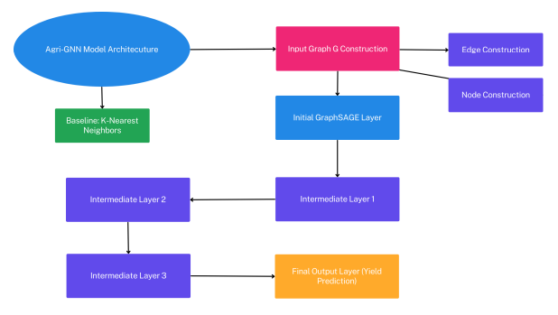

Ease of Use

A.

Simplicity for Farmers:

Agri-GNN is easy for farmers to use. They log in with their phone number, enter basic crop details, and instantly get the predicted yield with a confidence score to help in better planning.

Access for Researchers:
Researchers can log in securely to upload data, retrain the model, and analyze results to improve accuracy.

User-Friendly Design:

The web app, built with React.js and TailwindCSS, has a clean, responsive design that works on all devices, making it easy for farmers and researchers to use.

B. Maintaining the Integrity of the System

Agri-GNN ensures accurate and reliable results by maintaining data and model integrity throughout development. The backend keeps preprocessing, graph construction, and prediction modules separate to prevent data leakage and maintain consistency. During preprocessing, farmer inputs like soil, rainfall, and temperature are checked for missing or invalid values, and outliers are handled to avoid bias. The same format is used when researchers upload new datasets for retraining. Model parameters such as layers, learning rate, and aggregation functions remain fixed to ensure consistent and trustworthy predictions across all datasets.

System Architecture

Before building the Agri-GNN model, the system was designed with a three-tier architecture to manage data flow and communication between all components— Frontend, Backend, and Model Tier, supported by a common Database.
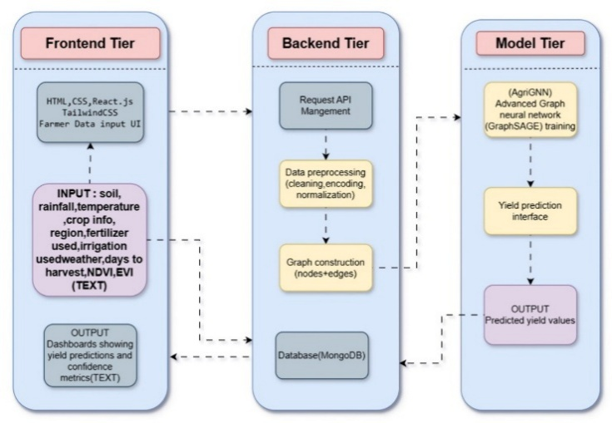

Frontend Layer
The frontend is the user-facing part of the system. Farmers log in using only their phone number for quick access. Researchers have an authenticated login to monitor models and manage datasets. Built with React.js, the interface allows users to enter inputs like soil, rainfall, temperature, crop, fertilizer, irrigation, and days to harvest. Farmers can view the predicted yield and confidence score on their dashboard.

Backend Layer
Developed using Flask/Django, the backend handles validation, preprocessing, and communication with the model. It receives user data, cleans and normalizes it, sends it to the model for prediction, and stores the results in the database.

Model Tier
This layer hosts the Graph Neural Network (GraphSAGE) model. It represents farms as nodes and their relationships (like soil, rainfall, and temperature similarity) as edges to learn patterns and predict yield accurately.

Database Layer
The MongoDB/MySQL database stores all user inputs, environmental details, and prediction results. It ensures both farmers and researchers have access to consistent, accurate, and retrievable data at any time.

Abbreviations and Acronyms
The following abbreviations and acronyms are used throughout this paper:
AI – Artificial Intelligence
ML – Machine Learning
GNN – Graph Neural Network
NDVI – Normalized Difference Vegetation Index
EVI – Enhanced Vegetation Index
API – Application Programming Interface
UI – User Interface
DB – Database
CSV – Comma-Separated Values (file format used for datasets)
Agri-GNN – Agricultural Graph Neural Network (name of our proposed model).

Units:
All measurements in this project follow standard SI (MKS) units for consistency and accuracy. Rainfall is measured in millimeters (mm), temperature in degrees Celsius (°C), soil moisture in percentage (%), and crop yield in kilograms per hectare (kg/ha). Land area is expressed in hectares (ha).
To maintain uniformity, any non-SI data is automatically converted into SI units before processing by the Agri-GNN model.

Equations

In the Agri-GNN model, each farm or region is represented as a node with its corresponding features such as soil properties, rainfall, temperature, and vegetation indices (NDVI, EVI). The relationship between neighboring farms is represented as edges, forming a connected graph.

The Graph Neural Network (GNN) updates each node’s feature representation by aggregating information from its neighbors. This process can be mathematically represented as:

h_{v}^{(k )} = σ (W^{(k)} ⋅ AGGREGATE ({h_{u}^{(k−1)} , ∀u ∈ N(v)}) + b^{(k)})

Where,
h_{v}^{(k )} → the feature vector of node v at layer k
N(v) → the set of neighboring nodes of v
AGGREGATE() → function used to combine neighbor information (mean, sum, or attention)
W^{(k)} , b^{(k)} → trainable parameters (weights and biases)
σ → activation function (e.g., ReLU)

The final predicted crop yield (Y) for a farm node is given by:
Y = f (h_{v} ^{(L)})
Where,
𝐿 is the last layer of the network and
𝑓 is a fully connected output layer.

Some common mistakes

To maintain clarity and accuracy, the following common mistakes were carefully avoided during the project:

Consistent Terminology: All technical terms such as NDVI, EVI, and GNN were defined and used consistently.

Proper Units: Every measurement (rainfall, temperature, yield, etc.) followed standard SI units.

Data Quality: Duplicate or missing data entries were removed before model training.

Formatting Consistency: Uniform headings, spacing, and labeling were maintained throughout the report.

Correct Notation: Scientific symbols and abbreviations were written correctly and clearly.

Dataset Integrity: Values were cross-checked to ensure no incorrect or out-of-range inputs were used.

System Overview and Implementation

Authors and Affiliations
The Agri-GNN Crop Yield Prediction project was developed by Group G619, a team of third-year students, under the guidance of Dr. Shilpa Gupta. The group members collaboratively worked on different parts of the system, including dataset preprocessing, model training, frontend design, and backend integration.
The project focuses on building an advanced Graph Neural Network–based framework for predicting crop yield using key agricultural parameters such as soil type, rainfall, temperature, irrigation, fertilizer usage, and vegetation indices (NDVI and EVI). The system was designed, implemented, and tested as part of the group’s academic research work in collaboration with publicly available agricultural datasets.

System Components
Frontend: Built using React.js for dynamic user interfaces where farmers can easily input crop data and view yield predictions. The interface is designed to be simple, responsive, and easy to navigate, even for users with minimal technical experience.
Backend: Developed with Django to handle data processing, user authentication, and integration with the trained GraphSAGE model. It acts as a bridge between the frontend, model, and database, ensuring smooth data flow and secure communication.
Database: Uses MySQL for storing farmer data, weather parameters, crop records, and yield outputs. It also keeps a record of previous predictions, which can be used for analysis and model improvement.
Model Integration: The Graph Neural Network model is trained using agricultural parameters such as soil, rainfall, temperature, NDVI, and EVI to predict yield efficiently. The model continuously improves as more data is added by farmers and researchers.

Table
Traditional Machine Learning Models | Proposed Agri-GNN Framework
Uses flat tabular data without relational context. | Represents agricultural data as graphs with nodes (regions, crops) and edges (climatic and environmental relationships).
  Treats features independently, missing spatial and contextual dependencies.
  Captures interdependencies between multiple agricultural factors like soil, rainfall, temperature, and vegetation indices.
  Performance drops with large heterogeneous data.
  Scales effectively by using GraphSAGE for inductive learning on unseen nodes.
  Needs retraining for new data or unseen conditions.
  Learns from neighbourhood patterns, adapting to new or missing data efficiently.
  Limited accuracy due to linear correlations and lack of spatial awareness.
  Improved accuracy through multi-factor relational learning and dynamic neighbourhood aggregation.
 | Integrates multimodal data like weather, NDVI, EVI, soil, and irrigation info for precision yield prediction.
  Works mainly on structured datasets.

Conclusion

The Agri-GNN model demonstrates a powerful and modern approach to crop yield prediction in today’s climate-affected agricultural environment. By using Graph Neural Networks, Agri-GNN captures the complex relationships between soil, weather, crop, and regional factors within a connected framework. Unlike traditional models that analyse features separately, Agri-GNN treats the entire farming ecosystem as an interconnected network, leading to more accurate and realistic yield predictions.
Its modular and flexible design allows continuous updates with new data sources, making it adaptable for future agricultural needs. The experimental results show that Agri-GNN achieves strong performance in terms of RMSE, MAE, and R² values, proving its effectiveness over existing models.
Overall, Agri-GNN is a step forward toward precision and sustainable agriculture, helping farmers and researchers make data-driven decisions that improve productivity while maintaining environmental balance.

Acknowledgment
The authors would like to express their sincere gratitude to Dr. Shilpa Gupta, for her continuous guidance, motivation, and valuable feedback throughout the development of this project. Her insights and encouragement have been essential for the successful completion of Agri-GNN: Crop Yield Prediction Using Graph Neural Networks for Precision Agriculture.
The team also extends heartfelt thanks to the department faculty and the institution for providing the required resources, support, and opportunity to carry out this research work. Finally, the authors appreciate the collaborative efforts and dedication of all team members who contributed to every stage of the project.

References
• Fan, J., Bai, J., Li, Z., Ortiz-Bobea, A., Gomes, C. (2021). A GNN-RNN Approach for Harnessing Geospatial and Temporal Information: Application to Crop Yield Prediction. Unpublished manuscript. arXiv
• Sun, X., Zhang, L., … (2024). Maize Yield Prediction with Trait-Missing Data via Bipartite Graph Neural Network. Frontiers in Plant Science. Frontiers
• Jabed, M. A., et al. (2024). Crop Yield Prediction in Agriculture: A Comprehensive Review of AI Techniques. Heliyon. PMC+1
• Ingole, V. S., Kshirsagar, U. A., Singh, V., Yadav, M. V., Krishna, B., Kumar, R. (2025). A Hybrid Model for Soybean Yield Prediction Integrating Convolutional Neural Networks, Recurrent Neural Networks, and Graph Convolutional Networks. Computation, 13(1), 4. MDPI
• Gupta, A., & Singh, A. (2023). Agri-GNN: A Novel Genotypic-Topological Graph Neural Network Framework Built on GraphSAGE for Optimized Yield Prediction. arXiv preprint. arXiv+1

